# Buy and Hold Benchmark Strategy

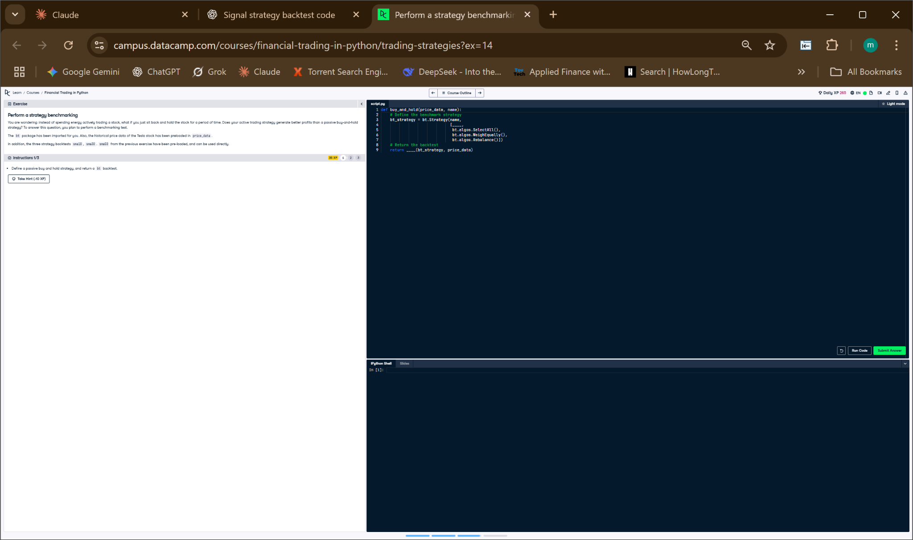

## Python Code

def buy_and_hold(price_data, name):  
 # Define the strategy  
 bnh_strategy = bt.Strategy(name,  
 [bt.algos.SelectAll(),  
 bt.algos.WeighEqually(),  
 bt.algos.Rebalance()])  
  
 # Return the backtest  
 return bt.Backtest(bnh_strategy, price_data)

## Explanation

This function defines a passive buy-and-hold strategy by selecting all stocks, assigning them equal weight, and rebalancing once. It mimics a basic long-term investment without trading. The function returns a backtest object so its performance can be compared to more active strategies.